

SYSTEM ANALYSIS AND DESIGN
FOR
A Cloud-Based Marketplace for Farmers

Valentine Mbinya - SCT121-0512/2024
Pauline Muthoni – SCT121-0511/2024

CHAPTER THREE 2
3.0 Introduction 2
3.1 System Analysis 2
3.1.1 Stakeholder Analysis 2
3.1.2 Existing System Analysis 3
3.1.3 Requirements Analysis 3
3.2 System Design 4
3.2.1 Class Diagram Description 5
3.2.2 Use Case Design 6
3.2.3 Sequence Diagram Description 9
3.2.4 Activity Diagram Description 11
3.2.5 Component Diagram Description 13
3.2.6 Deployment Diagram Description 14
3.3 Database Design (ERD) 15
3.3.1 Identified Entities 15
3.3.2 Entity Relationships 16
3.3.3 Primary and Foreign Keys 16
3.3.4 Constraints and Validation Rules 16
3.3.5 Normalization 17
3.4 User Interface Design 17
3.4.1 Farmer Interface 17
3.4.2 Buyer Interface 17
3.4.3 Administrator Interface 18
3.15 Security Design 18
3.5.1 Authentication and Authorization 18
3.5.2 Data Security 18
3.5.3 Payment Security 18
3.5.4 Blockchain-Based Trust 19
3.6 Technology Stack 19
3.6.1 Presentation Layer 19
3.6.2 Application Layer 19
3.6.3 Data Layer 19
3.6.4 External Services 19

SYSTEM ANALYSIS AND DESIGN

CHAPTER THREE

3.0 Introduction
This chapter presents a detailed system analysis and design of the JonaFarm Market System. The purpose of this chapter is to explain how the system will operate in practice and how it will be technically structured before actual implementation begins.
The analysis focuses on real challenges experienced by farmers and buyers in agricultural trade, including unfair pricing, lack of trust, limited market access, and delayed payments. By studying how agricultural trading currently occurs, clear system requirements are identified to guide the system design.
The chapter covers stakeholder analysis, existing system analysis, system requirements, use case analysis, and system design. The design section outlines the system architecture, database design, data flow diagrams, user interface design, security design, and technology stack. This chapter serves as a blueprint that guides the development and implementation of the system.

3.1 System Analysis
System analysis examines the current agricultural trading environment to identify existing challenges and define the functional and operational requirements of the JonaFarm Market System. This analysis focuses on real-world interactions among farmers, buyers, and service providers to ensure that the proposed system effectively addresses practical problems in agricultural trade.

3.1.1 Stakeholder Analysis
The JonaFarm Market System interacts with multiple stakeholders, each playing a critical role in the operation and success of the system.
Farmers
Farmers are the primary suppliers of agricultural products within the system. They register and log in to the platform to create and manage product listings by providing details such as price, quantity, and harvest date. Farmers receive notifications when orders are placed and receive payments directly through the integrated M-Pesa payment system.
Buyers
Buyers are customers who purchase agricultural products through the platform. They browse available products, compare prices, place orders, and make online payments. Buyers can also track order status and view their transaction history.
System Administrator
The system administrator oversees overall system operations. Responsibilities include managing user accounts, approving or suspending users, handling reported issues, and monitoring transactions to ensure system integrity and smooth operation.
Payment Gateway (M-Pesa)
M-Pesa serves as an external payment gateway responsible for processing all financial transactions. It securely handles payments and sends transaction confirmations to the system upon successful completion.
Distributors
Distributors act as intermediaries responsible for the transportation and delivery of agricultural products from farmers to buyers. Within the JonaFarm Market System, distributors register and log in to access delivery requests associated with confirmed orders. They receive order details such as pickup location, delivery address, product quantity, and delivery timelines.
Distributors update delivery status (e.g., picked up, in transit, delivered), enabling real-time order tracking for both farmers and buyers. Their involvement ensures efficient logistics management, timely deliveries, and improved supply chain coordination within the platform.
Blockchain Service
The blockchain service operates in the background to support product verification. It records verification data in an immutable manner to prevent tampering and enhance trust between farmers and buyers.

3.1.2 Existing System Analysis
Currently, agricultural trading in many regions operates through local markets and intermediaries. Farmers primarily sell their produce through middlemen who control pricing, often resulting in unfair compensation. Payment processes remain largely informal and manual, leading to delayed or inconsistent payments and a lack of reliable transaction records.
Buyers depend on physical market visits to purchase agricultural products, which limits their access to accurate information regarding product origin, quality, and pricing. The absence of digital tracking systems makes it difficult to verify product authenticity, increasing the risk of fraud and reducing buyer trust.
Overall, the existing system lacks transparency, efficiency, and accountability. These limitations negatively affect both farmers and buyers and highlight the need for a centralized, technology-driven marketplace.
Challenges Identified:
- Farmers receive low and inconsistent prices due to intermediary control
- Payments are delayed and unreliable
- Farmers have limited access to wider markets
- Buyers lack trust due to poor product traceability
- There are no centralized or secure transaction records

3.1.3 Requirements Analysis
System requirements specify the functionalities and quality attributes that the JonaFarm Market System must provide in order to address the challenges identified in the existing agricultural trading process. These requirements are categorized into functional and non-functional requirements to ensure clarity and completeness.

3.1.3.1 Functional Requirements
The JonaFarm Market System shall:
- Allow farmers, buyers, and administrators to register and log in securely
- Enable farmers to create, update, and manage agricultural product listings
- Allow buyers to search, view, and compare available products
- Enable buyers to place orders through the system
- Process online payments using the M-Pesa payment gateway
- Automatically update order and payment statuses in real time
- Record and store product verification information using blockchain technology
- Allow administrators to manage user accounts and monitor system transactions

3.1.3.2 Non-Functional Requirements
The JonaFarm Market System shall:
- Provide fast and responsive interaction for all users
- Ensure data security through encryption and secure authentication mechanisms
- Support access through both mobile and desktop devices
- Maintain high system availability with minimal downtime
- Be scalable to accommodate an increasing number of users and transactions

3.2 System Design
This chapter presents the detailed design of the JonaFarm system. It explains how the system is structured, how users interact with it, and how different components work together to achieve the required functionality. UML diagrams are used to clearly illustrate the system design.
3.1 Architectural Design
The JonaFarm system follows a three-tier architecture, which separates system responsibilities into three logical layers. This architecture improves scalability, security, and maintainability.
- Presentation Layer (Web/Mobile Interface):
This layer provides the user interface for all system users, including farmers, buyers, administrators, and delivery distributors. Through this layer, users can register, log in, add products, view products, place orders, and confirm deliveries. It communicates user requests to the application layer and displays responses back to users.
- Application Layer (Business Logic):
This layer handles all core system operations and business rules. It manages product listing and approval, order processing, payment validation, and delivery confirmation. It also coordinates communication between the presentation layer, database, and external services such as the M-Pesa payment system.
- Data Layer (Cloud Database):
The data layer stores all persistent system data, including user details, product information, orders, payments, and transactions. A cloud-based database ensures data availability, backup, and scalability.

3.2.1 Class Diagram Description
The class diagram describes the static structure of the JonaFarm system by identifying key classes, their attributes, methods, and relationships.
Key Classes:
- User: A general class containing common attributes such as userID, name, phoneNumber, password, and role.
- Farmer, Buyer, Admin: Specialized classes that inherit from the User class and define role-specific behaviors.
- Product: Stores product details such as productID, name, price, quantity, and approval status.
- Order: Represents a buyer’s order and includes orderID, orderDate, status, and total amount.
- Payment: Contains payment details linked to an order.
- Transaction: Stores transaction reference numbers and payment confirmations.
The class diagram supports object-oriented design principles such as encapsulation, inheritance, and association.

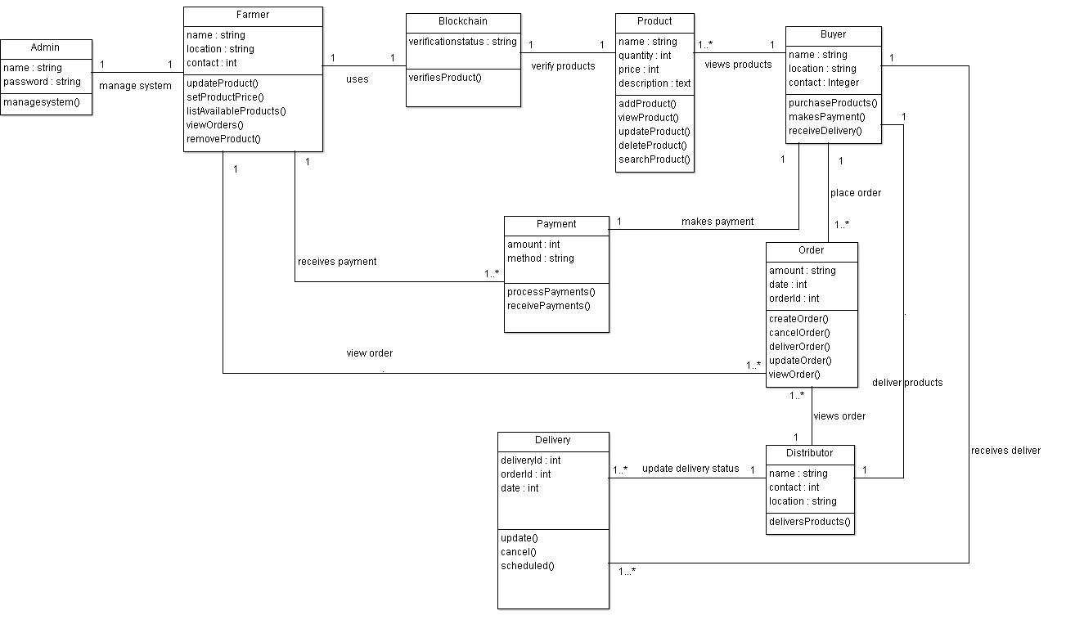

3.2.2 Use Case Design
The use case design illustrates how different actors interact with the JonaFarm system to achieve specific goals.
Actors:
- Farmer: Registers in the system, adds products, updates prices, and manages listings.
- Buyer: Views products, places orders, makes payments, and confirms delivery.
- Admin: Reviews and approves products before they are visible to buyers.
- Payment System (M-Pesa): Processes mobile money payments.
- Delivery Distributor: Delivers approved and paid orders to buyers.
Main Use Cases:
- Register/Login
- Add Product
- Update Product
- Approve Product
- View Products
- Place Order
- Make Payment

3.2.1.1 Generic Use Case Diagram
The generic use case diagram provides a high-level view of system functionality without focusing on a specific user instance. It shows the major system operations such as registering, managing products, placing orders, approving products, and making payments. This diagram helps define system boundaries and overall functionality.
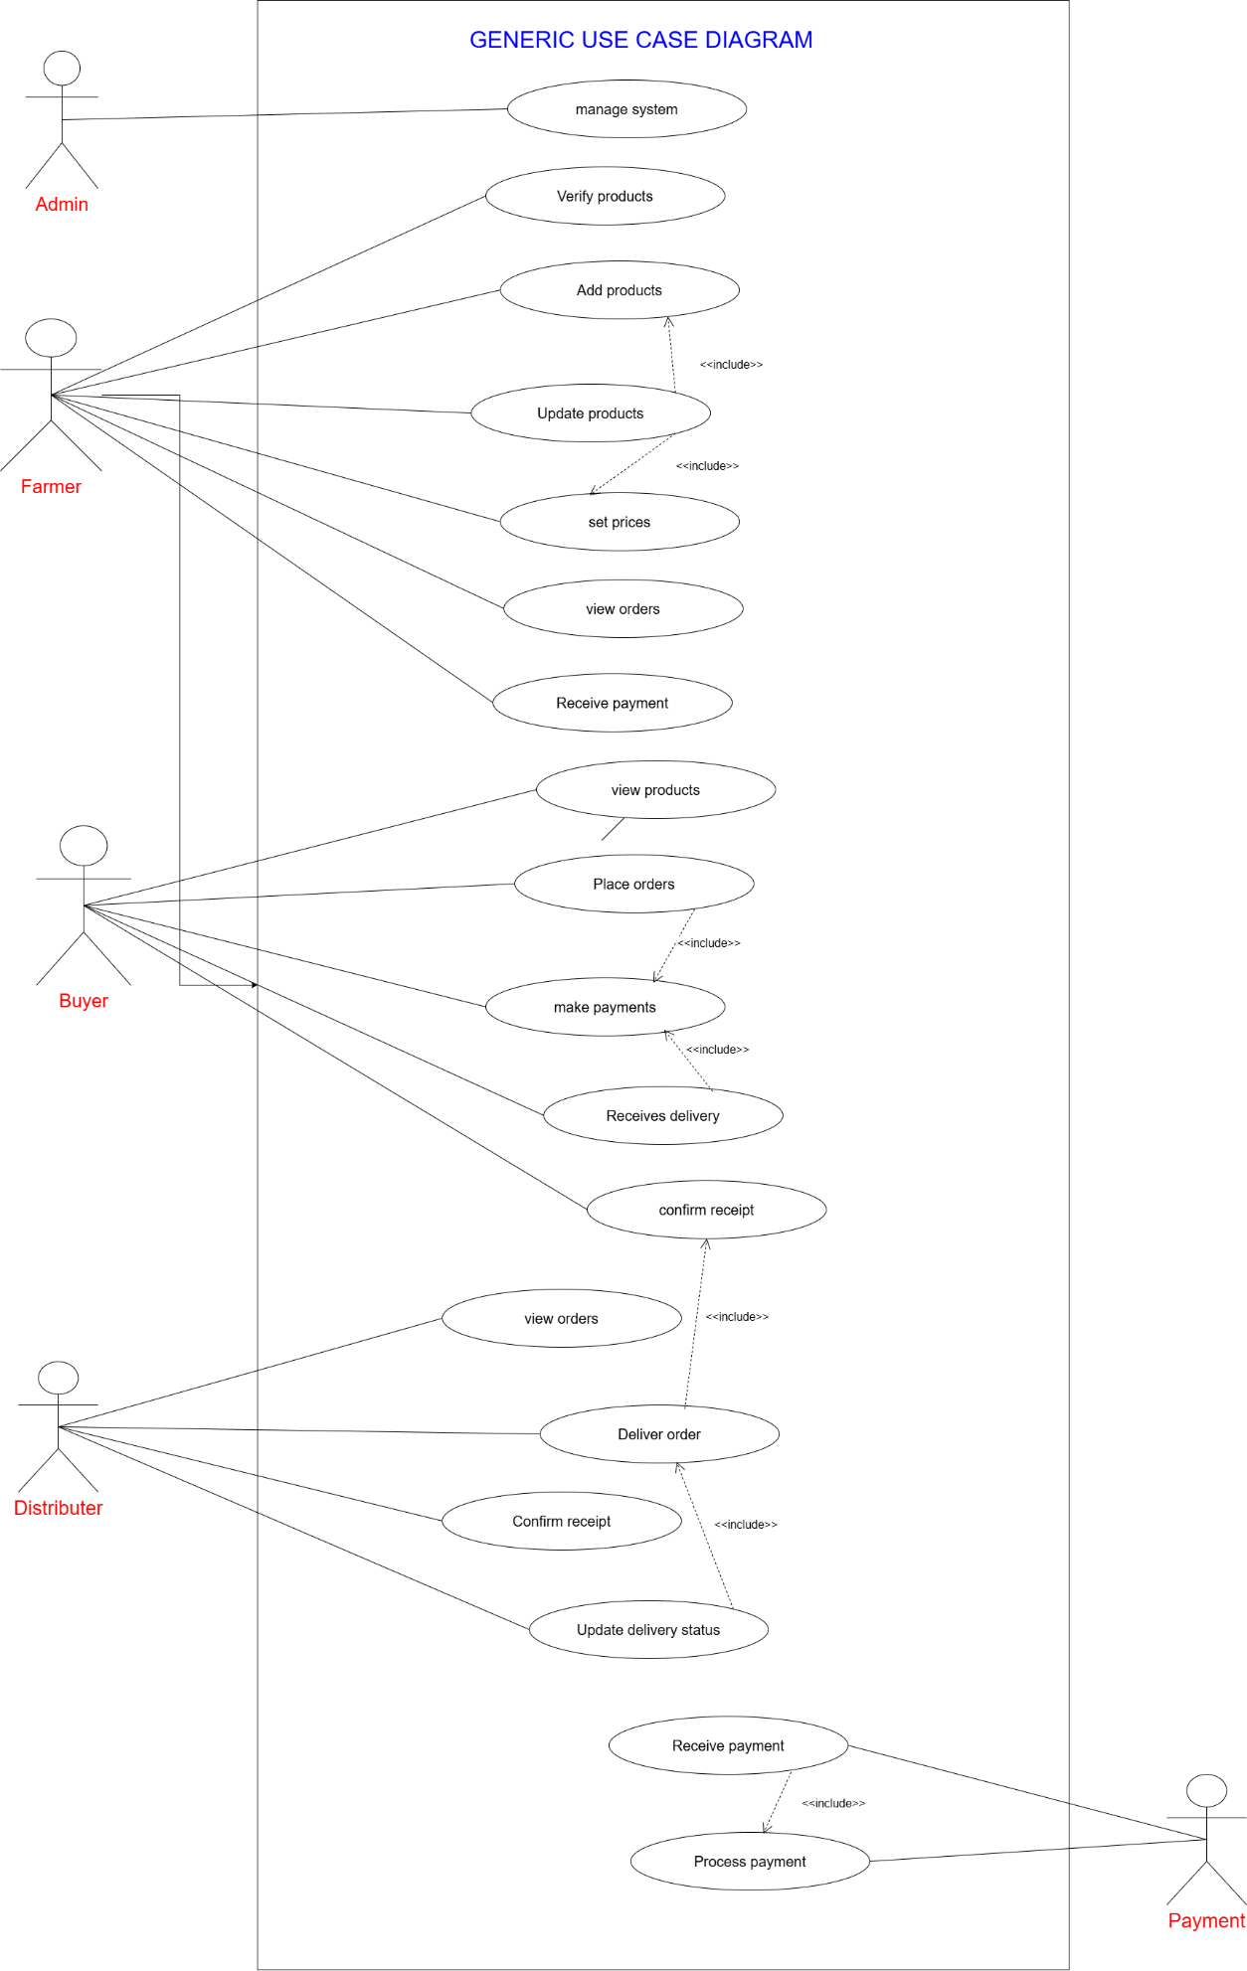

3.2.1.2 Instance Use Case Diagram
The instance use case diagram demonstrates how specific users interact with the system in a real-life scenario.
Scenario Description:
Farmer John adds Tomatoes and Onions to the JonaFarm Market System, updates their prices, and lists them for buyers. Admin Alice reviews and approves the products. Buyer Mary selects the products and places Order #123. She makes payment via M-Pesa Transaction #001, which is processed by the payment system. JonaFarm Delivery Distributors delivers the order, and Mary confirms receipt.
This diagram clearly shows how individual actors collaborate to complete a full business process.

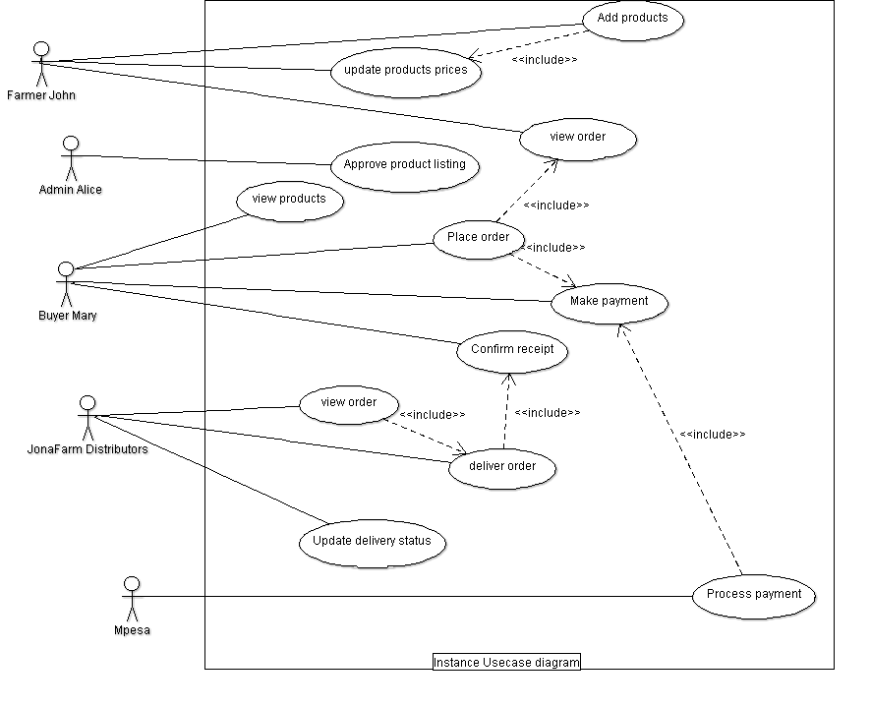

3.2.3 Sequence Diagram Description
Sequence diagrams illustrate the interaction between actors and system components over time.

3.2.3.1 Generic Sequence Diagram
The generic sequence diagram shows the normal flow of interactions during product listing, approval, ordering, and payment without focusing on specific users. It highlights how requests and responses move between system objects.

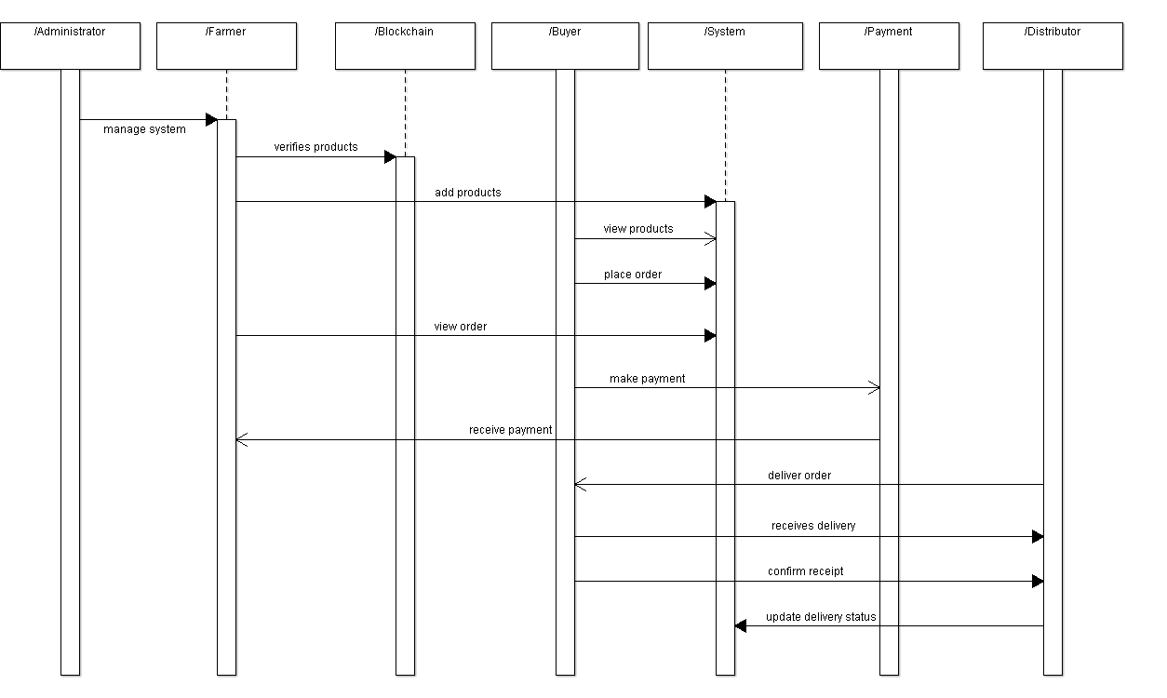

3.2.3.2 Instance Sequence Diagram
The instance sequence diagram is based on a real scenario involving specific users.
Scenario Description:
Farmer John adds Tomatoes and Onions to the JonaFarm Market System and updates their prices. Admin Alice reviews and approves the products. Buyer Mary selects the products and places Order #123. She makes payment via M-Pesa Transaction #001, which is processed by the payment system. The delivery distributor delivers the products, and Mary confirms receipt.
This diagram emphasizes message order, system validation, and external service interaction.
She makes payment via M-pesa Transaction #001, which is processed by the payment system.
JonaFarm Delivery Distributors delivers the order, and Mary confirms receipt.

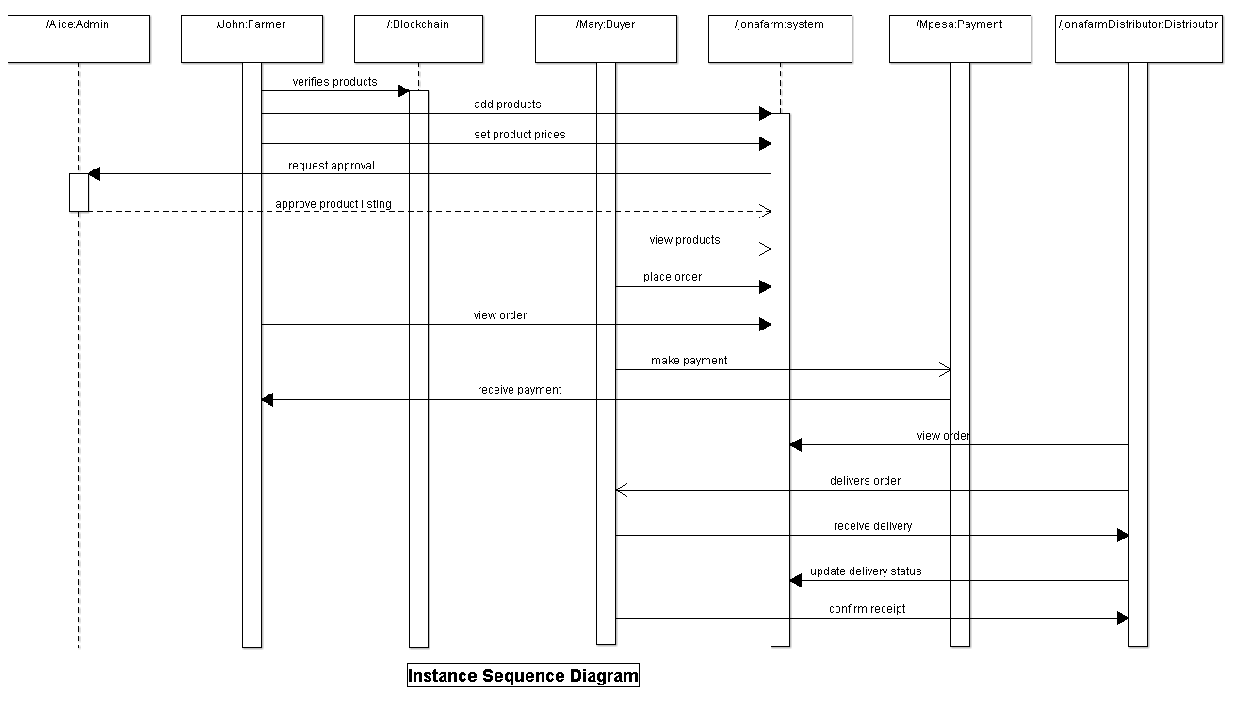

3.2.4 Activity Diagram Description
Activity diagrams represent workflows and business processes within the system.
For example, the product approval and order processing workflows begin when a farmer adds a product, continue through admin approval, buyer ordering and payment, and end with delivery confirmation. Decision points such as approval or rejection and payment success or failure are clearly illustrated.

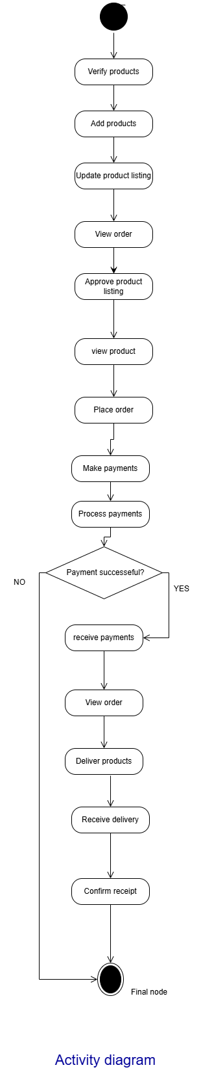

3.2.5 Component Diagram Description
The component diagram shows the system’s modular structure and how different components interact.
Internal Components:
- User Management Component
- Product Management Component
- Order Management Component
- Payment Integration Component
- Database Services Component
External Components:
- M-Pesa Payment API
- Cloud Hosting Services
Interfaces are used to show communication between components, ensuring loose coupling and easier maintenance.

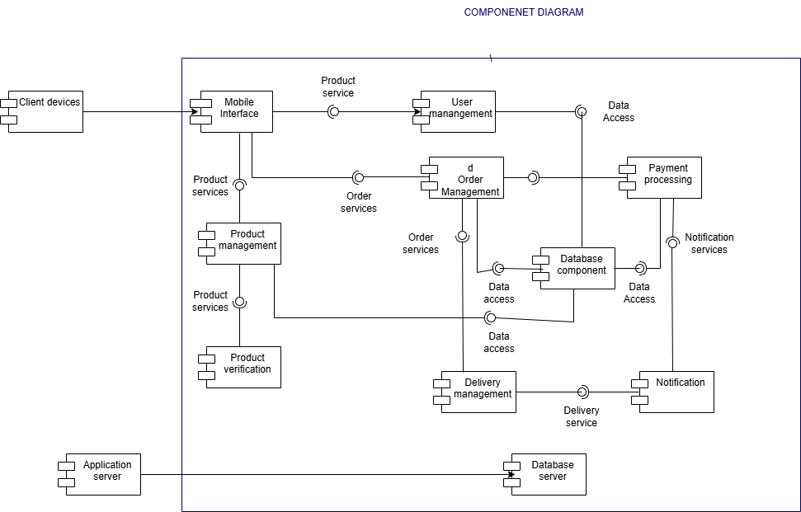

3.2.6 Deployment Diagram Description
The deployment diagram illustrates how the JonaFarm system is physically deployed in a real-world environment.
Client devices, including web browsers and mobile applications, are used by farmers, buyers, administrators, and delivery distributors to access the system. These client devices connect to a cloud-hosted web server through the internet. The web server forwards requests to the application server, which hosts the business logic of the system.
The application server communicates with a cloud-based database server that stores all system data such as users, products, orders, payments, and transactions. The application server also integrates with the external M-Pesa payment gateway for payment processing and the blockchain service for product verification.
Cloud deployment was chosen to ensure scalability, high availability, data backup, and fault tolerance. This architecture allows the system to handle increasing numbers of users and transactions efficiently.

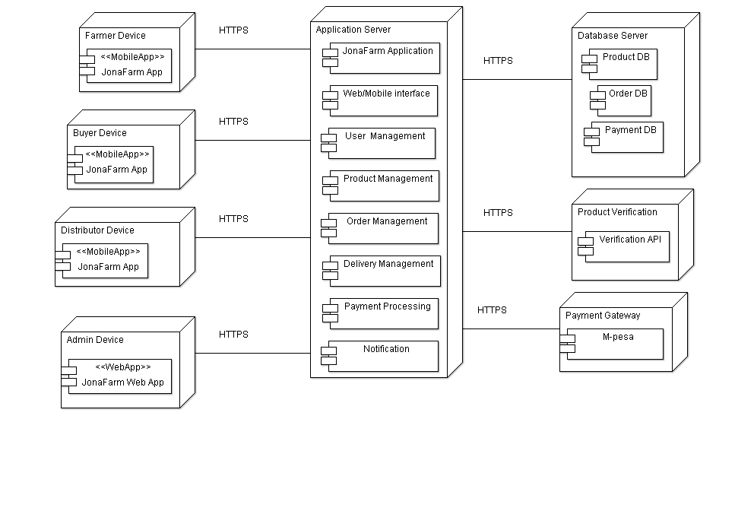

3.3 Database Design (ERD)
The database design defines how data is structured, stored, and related within the JonaFarm Market System. It ensures data integrity, consistency, and efficient access to support system operations such as product listing, ordering, payment processing, and transaction tracking. The Entity Relationship Diagram (ERD) is used to visually represent entities and their relationships.

3.3.1 Identified Entities
The main entities identified in the JonaFarm Market System include:
- User – Represents all system users, including farmers, buyers, administrators, and delivery distributors.
- Product – Represents agricultural products listed by farmers for sale.
- Order – Represents purchase requests made by buyers.
- Payment – Stores payment details associated with orders.
- Transaction – Records payment transaction confirmations and references from the payment gateway.
These entities reflect real-world objects and processes involved in agricultural trading.

3.3.2 Entity Relationships
The relationships between entities are defined as follows:
- A Farmer (User) can list many Products (One-to-Many relationship).
- Each Product is associated with one Farmer.
- A Buyer (User) can place many Orders (One-to-Many relationship).
- Each Order is associated with one Buyer.
- Each Order has one Payment (One-to-One relationship).
- A Payment may be linked to one or more Transactions to handle confirmations or retries.
These relationships ensure logical data flow and support system functionality.

3.3.3 Primary and Foreign Keys
Primary and foreign keys are used to uniquely identify records and establish relationships between tables.
- Users Table
  - Primary Key: userID
- Products Table
  - Primary Key: productID
  - Foreign Key: farmerID → Users(userID)
- Orders Table
  - Primary Key: orderID
  - Foreign Key: buyerID → Users(userID)
- Payments Table
  - Primary Key: paymentID
  - Foreign Key: orderID → Orders(orderID)
- Transactions Table
  - Primary Key: transactionID
  - Foreign Key: paymentID → Payments(paymentID)
These keys enforce referential integrity and prevent invalid or orphan records.

3.3.4 Constraints and Validation Rules
To ensure data accuracy and reliability, the following constraints are applied:
- NOT NULL constraints on critical fields such as userID, product name, price, and order status
- UNIQUE constraint on phone numbers to prevent duplicate user accounts
- CHECK constraints to ensure valid values (e.g., price > 0, quantity ≥ 0)
- Status fields to control system states such as Pending, Approved, Paid, and Delivered
These rules maintain database consistency and reduce data errors.

3.3.5 Normalization
The database design follows Third Normal Form (3NF) to eliminate redundancy and dependency anomalies:
- User information is stored only in the Users table
- Product data is separated from order data
- Payment and transaction details are stored in separate tables
Normalization improves data integrity, minimizes duplication, and simplifies system maintenance.

3.4 User Interface Design
The user interface design focuses on simplicity, usability, and accessibility to accommodate users with varying levels of technical expertise, particularly small-scale farmers.

3.4.1 Farmer Interface
The farmer interface enables farmers to manage their products and sales activities. It allows farmers to:
- Add, update, and manage product listings
- View product approval status
- View customer orders
- Track payments received
The interface is designed to be straightforward and easy to use.

3.4.2 Buyer Interface
The buyer interface allows buyers to interact with the marketplace and make purchases. Key features include:
- Browsing and searching available products
- Viewing product details and prices
- Placing orders
- Making payments via M-Pesa
- Tracking delivery status and confirming receipt
This interface enhances transparency and user trust.

3.4.3 Administrator Interface
The administrator interface provides system control and monitoring capabilities, including:
- Managing user accounts
- Approving or rejecting product listings
- Monitoring orders and payments
- Viewing system activity logs and reports
This interface ensures effective system administration and security oversight.

3.15 Security Design
Security design ensures the protection of system data, financial transactions, and user activities.

3.5.1 Authentication and Authorization
The system uses secure authentication mechanisms that require users to log in using unique credentials. Role-Based Access Control (RBAC) ensures that users can only access features relevant to their assigned roles.

3.5.2 Data Security
Sensitive data such as passwords and transaction information is encrypted before storage. Secure communication protocols are used to protect data transmitted between clients and servers.

3.5.3 Payment Security
All financial transactions are processed through the M-Pesa payment gateway. The system does not store sensitive payment credentials, reducing the risk of financial data exposure.

3.5.4 Blockchain-Based Trust
Blockchain technology is used to store product verification records in an immutable manner. This enhances transparency, prevents data tampering, and builds trust between farmers and buyers.

3.6 Technology Stack
This section outlines the technologies used to implement the JonaFarm Market System.

3.6.1 Presentation Layer
The presentation layer consists of a web-based interface accessible through modern browsers and a mobile-friendly design to support smartphone users.

3.6.2 Application Layer
The application layer implements business logic, handles user requests, manages workflows, and integrates external services such as M-Pesa and blockchain platforms.

3.6.3 Data Layer
The data layer uses a cloud-hosted relational database management system to store structured system data securely and efficiently.

3.6.4 External Services
- M-Pesa API – Used for mobile payment processing
- Blockchain Platform – Used for product verification and transaction integrity
The selected technology stack ensures scalability, security, and maintainability of the system.

